

HELP MODULE

Release Note

www.projectobjects.com

support@projectobjects.com

Table of Contents

Overview: 3

HELP ADMIN: 3

Create HELP: 3

HELP for object-type project homepage layouts, app pages, and process: 4

BASe url setting: 4

View Help: 5

# Overview:

In this release, we have implemented the **HELP** module over the application. The purpose of this module is to helps the new users about the various modules of the application or show help how to use different modules of the application. Using this module, users can also create help, and make it visible to other users in different modules of the application. Users can add web-references, PDF, Video, Audio, attachments for the HELP.

## HELP ADMIN:

Here we have added a new module **Help Admin** in the company settings page, which redirects us to the HELP register where users can create help.

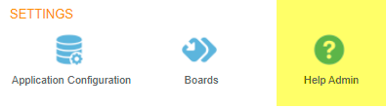

## Create HELP:

Create new button is given on the HELP register page. Click on the create a new button and fill required details in the pop-up.

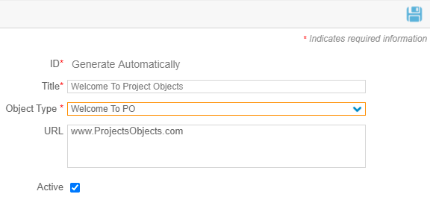

* Similar to the **Object Type “Welcome To PO”**, a user can create help for object types **Technical Notes** and **FAQ.**
* Help for object type Welcome To PO, Technical Note, and FAQ will be visible in all the modules of the application.
* If Active is not checked in the pop-up, then help is not clickable.

## HELP for object-type project homepage layouts, app pages, and process:

To create the help for these object types, create new button is given and fill required data. Here we have added two more fields **“Sub Type”** and **“Help Type”.**

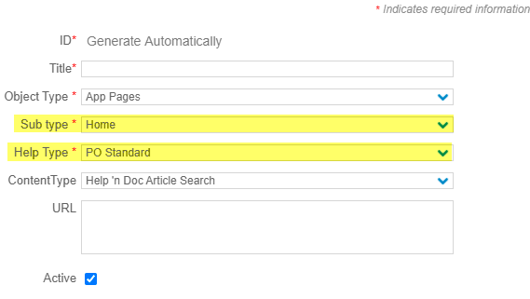

* If Help Type is **PO Standard** and **Customer**, then created help will be visible in the **HOW TO** section.
* If Help Type is **Resources**, then created help will be visible in the **RESOURCES** section.
* Help created for these object types is visible only in the respective modules or Sub Types.
* If Active is not checked in the pop-up, then created help will not be visible in the modules.

## BASe url setting:

We have added a Base URL Setting icon on the top right corner of the HELP register. Here user can save the base URL for **Help Type**, **PO Standard,** and **Customer** and only save the page name in the URL field of the help pop-up.

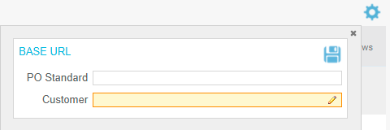

## View Help:

We have added a help icon beside the “MY Account” on the top right corner of the application.

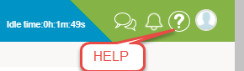

User can view help by clicking on the HELP icon:

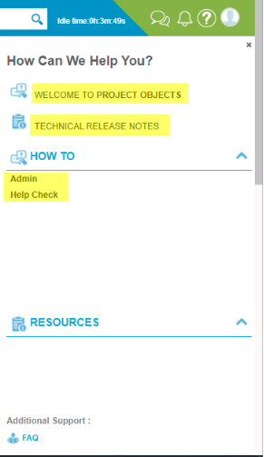

All the created help will be visible in this window respective to the Object Type and the user can view help by clicking on the created help which is visible in HOW TO and RESOURCES section.